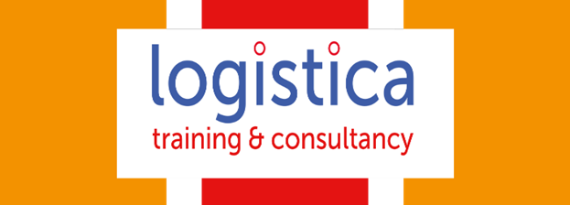

Logistica Training proudly offers Fully funded online Level 2 short courses. We have designed courses to support adults upskill and to assist their professional development. Learner will need to be 19 plus and live in a non-devolved Post Code area and not on any other funded course to be Eligible for Funding. You have 3 months to complete the course; Tutors are also available to support. Please check your postcode on this link below:
https://skillspostcodecheck.com/tool/

- Certificate in understanding Challenging behaviour

- Level 2 Certificate in Advice and Guidance

- Level 2 Certificate in Mental health Awareness

- Certificate in understanding Mental Health First Aid and Advocacy in the workplace

- Award in awareness of Dementia Care

- Certificate introducing caring for Children and Young People

- Certificate in principles of medication handling and administration for care settings

For more information on how to apply please contact – Julia Chiapparrone juliac@acaciatraining.co.uk

