Logging in to Google Classroom from a Tablet
Please download the following apps from the Apple App Store/Google Play Store:
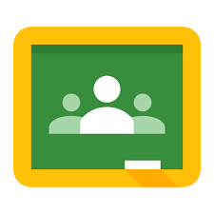 | 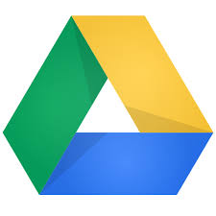 | 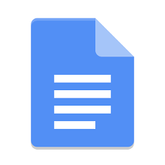 | 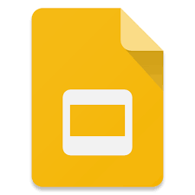 | 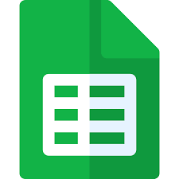
Google Classroom | Google Drive | Google Docs | Google Slides | Google Sheets

- Load up Google Classroom
- Press ‘Get Started’
- Log in using the details you have been given by your school
- Click ‘Accept’. You may have to scroll down.
- Press ‘I’m a Student’
- It is up to you if you would like to accept Notification. Press either ‘Don’t Allow’ or ‘Allow’
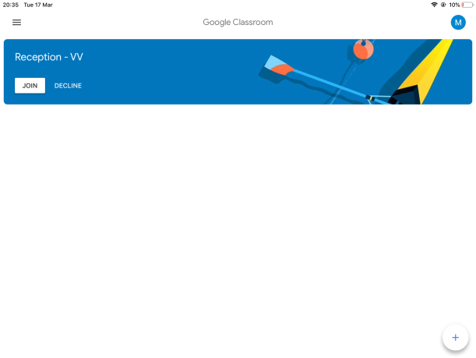
- You will now see your class. Click Join. If any classes you are not part of are listed, click Decline

