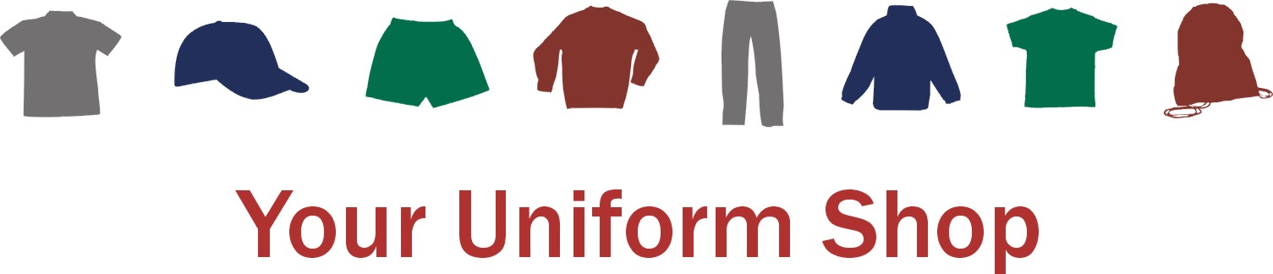

# How it Works

* Register or sign in by visiting the service provider’s website at [www.stitchdesign.co.uk](http://www.stitchdesign.co.uk). You will need to know the school’s post code to register.
* CH3 7QT
* Once registered you should place and pay for your order online.
* If you do not have online access then please check at the School Office for the available options.
* All items within Your Uniform Shop, and their prices, are fully approved by the school.
* An on-screen Sizing Guide for each item is available but, if you are not familiar with the garment, please ask at the school as there may be sizing samples available or specific days when uniform can be tried.
* Please double check your confirmation email to ensure everything is correct.
* Items will usually be despatched directly to you the following working day.
* Any problems with supply of any items will be communicated to you and despatched as soon as possible.

# Problems?

* Where available the Uniform Policy can be accessed via a link in Your Uniform Shop. If this is not available then please contact the school or check the school’s website.
* If you have any problems with the order process then please check the “Instructions & FAQ’s for Parents” page. Please contact Stitch Design if problems persist.
* If your order has not arrived within 5 working days please contact Stitch Design.
* If you think you need to return any items then please contact Stitch Design.

